Section1 -Convert Josh's comps into a HTML5 site Page 
We will be building Josh’s Wordpress site from a PSD. You will use this same method to build your Wordpress site for your clients.
This will involve-

The Overall Process
1-Download Bootstrap3 files from W3C or Getbootstrap.com
2- Copy and Paste a basic template from W3C or Getbootstrap.com
3- Add the bootstrap classes to the webpage, so that we get a grey box structure.
4-Copy and paste all our text from the design comp into the webpage adding HTML tags as we go- then Validate the HTML
5- Add our own custom CSS and media queries at break points- making sure the divs and structure flows in relation to content and screen widths
6- Use the index.HTML page as the basic template for all the Wordpress theme files.
7- Add Wordpress template files based on content and site structure
8- Assign specific Wordpress content to Div’s with styling

Convert Josh's comp into a HTML5 site using Bootstrap3

SECTION 1- Getting Started
We will be using Github Desktop to store all our files. Github desktop allows us to record all our coding work and revert to old versions if we break our code. Github is used throughout the industry.

1. Install Github Desktop https://desktop.github.com/ on your machine- Github Desktop is installed in the labs
2. Follow the Week 1 “How to use Github Desktop” tutorial up to 3.04min and make a Github Account
3. In the browser in Github in the top left hand corner, search for cyphem/starter_for_josh_site
Click on the link and then click on FORK
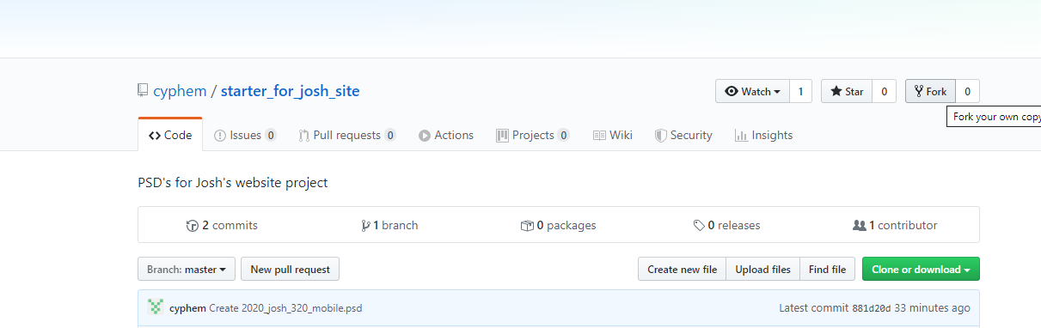
4. You will now see that you have the start_for_josh_site in you Github respository
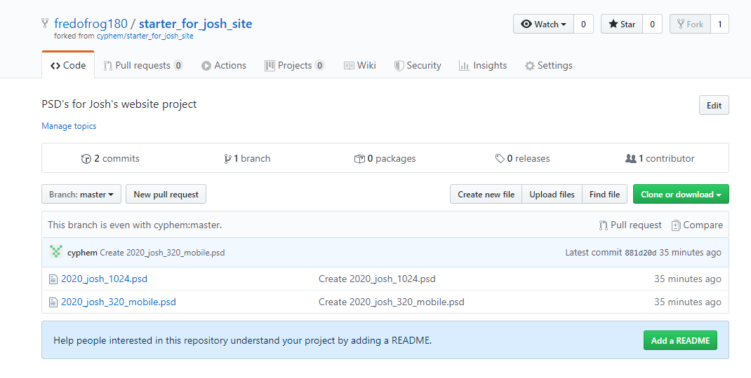

5. Now we want to clone this folder on our computer’s Github Desktop or Drive-
a Click on Clone or Download
b Open in Desktop
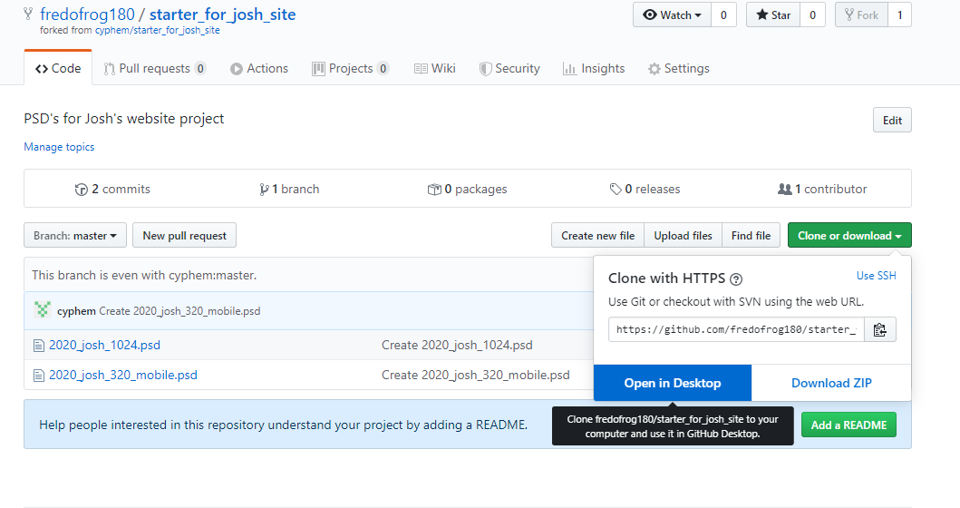
a
b
6. Choose the local path – which is your desktop or drive- and click CLONE
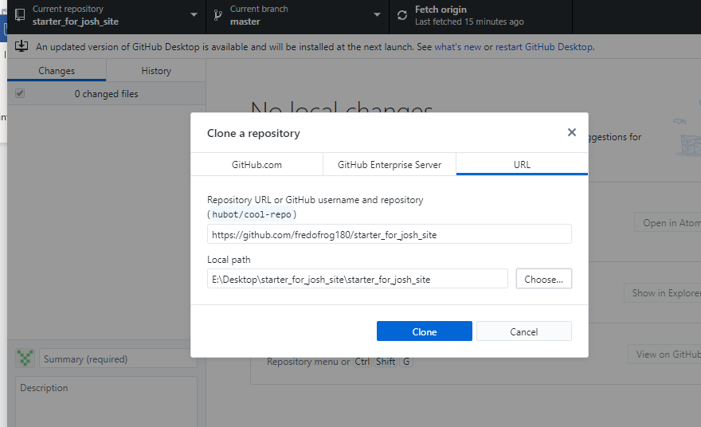

7. You should now have your starter_for Josh_site folder on the desktop. THIS WILL BE YOUR WORKING FOLDER FROM NOW ON

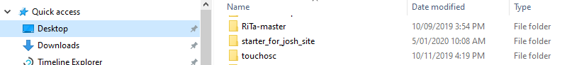

8. Open the mobile and desktop psd/ comps as well.
9. Find the local site folder in Brackets by going to the starter_for_joshs_site_folder which now probably sits on your desktop or drive.
In the Files section in Brackets you should see a list of the files in your Josh folder.

10. Open the mobile and desktop design PSD/comps in photohop so we have an idea of the structure.

Building the overall Bootstrap structure
1. Go to https://getbootstrap.com/docs/3.3/ (NOT version 4, because the web is full of a million blogs, sites and forums posts that can help us deal with all things Bootstrap3)
2. Download bootstrap- unzip the files to your josh folder
3. Click on getting started in the Bootstrap3 webpage, go half way down the page and copy and paste this code into a new HTLM5 doc

<!DOCTYPE html> <html lang="en"> <head> <meta charset="utf-8"> <meta http-equiv="X-UA-Compatible" content="IE=edge"> <meta name="viewport" content="width=device-width, initial-scale=1"> <!-- The above 3 meta tags *must* come first in the head; any other head content must come *after* these tags --> <title>Bootstrap 101 Template</title> <!-- Bootstrap --> <link href="css/bootstrap.min.css" rel="stylesheet"> <!-- HTML5 shim and Respond.js for IE8 support of HTML5 elements and media queries --> <!-- WARNING: Respond.js doesn't work if you view the page via file:// --> <!--[if lt IE 9]> <script src="https://oss.maxcdn.com/html5shiv/3.7.3/html5shiv.min.js"></script> <script src="https://oss.maxcdn.com/respond/1.4.2/respond.min.js"></script> <![endif]--> </head> <body> <h1>Hello, world!</h1> <!-- jQuery (necessary for Bootstrap's JavaScript plugins) --> <script src="https://ajax.googleapis.com/ajax/libs/jquery/1.12.4/jquery.min.js"></script> <!-- Include all compiled plugins (below), or include individual files as needed --> <script src="js/bootstrap.min.js"></script> </body> </html>

4. Save it as index.html

5. Go to https://www.w3schools.com/bootstrap/bootstrap_navbar.asp
Half way down the page there is an example of a collapsible navbar, used in mobiles.
You can copy and paste the navbar code into the <body> tag in our HTML page.

We need to make changes to this navbar
5a. You will need to float the menu items to the right by adding a navbar-right class to the ul class, this will push our menu items to the right
5b. Delete the glyphicon Ul class
5c. Add JOSHWHITKIN to the navbar-brand class

<nav class="navbar navbar-inverse">
<div class="container-fluid">
<div class="navbar-header">
<button type="button" class="navbar-toggle" data-toggle="collapse" data-target="#myNavbar">
<span class="icon-bar"></span>
<span class="icon-bar"></span>
<span class="icon-bar"></span>
</button>
<a class="navbar-brand" href="#">JOSH WHITKIN</a>
</div>
<div class="collapse navbar-collapse" id="myNavbar">
<ul class="nav navbar-nav navbar-right">
<li class="active"><a href="#">Home</a></li>
<li class="dropdown">
<a class="dropdown-toggle" data-toggle="dropdown" href="#">Page 1 <span class="caret"></span></a>
<ul class="dropdown-menu">
<li><a href="#">Page 1-1</a></li>
<li><a href="#">Page 1-2</a></li>
<li><a href="#">Page 1-3</a></li>
</ul>
</li>
<li><a href="#">Page 2</a></li>
<li><a href="#">Page 3</a></li>
</ul>
<ul class="nav navbar-nav navbar-right">
<li><a href="#"><span class="glyphicon glyphicon-user"></span> Sign Up</a></li>
<li><a href="#"><span class="glyphicon glyphicon-log-in"></span> Login</a></li>
</ul>
</div>
</div>
</nav>

5d. Now the li (list elements) in the navbar needs the proper tabs

<ul class="nav navbar-nav navbar-right">
<li class="active"><a href="#">HOME</a></li>
<li><a href="#">PROJECTS</a></li>
<li><a href="#">PUBLICATIONS</a></li>
<li><a href="#">CV</a></li>
<li><a href="#">CONTACT</a></li>
</ul>

(This code is not perfect, we still need to fix a lot of things, but for now we are just trying to get the overall structure right)

The main header area represents – “a group of introductory or navigational aids. A header element typically contains the section’s heading (an h1–h6 element or an hgroup element), but can also contain other content, such as a table of contents, a search form, or any relevant logos.”

Add the header
<header class="container-fluid”><!-- div for the main image the stretches to the edge of the page-->
<div class="container"><!-- div that holds the content in the middle of the page-->
<h1> Games Design For the future </h1><!-- the main tag line-->
</div><!-- container-->
</header>

The main background image is underneath the transparent menu bar, so we need to have the navbar inside the header. Move the opening header tag above the menu.

<header class="container-fluid ">

<nav class="navbar">
<div class="container-fluid">
<div class="navbar-header">
<button type="button" class="navbar-toggle" data-toggle="collapse" data-target="#myNavbar">
<span class="icon-bar"></span>
<span class="icon-bar"></span>
<span class="icon-bar"></span>
</button>
<a class="navbar-brand" href="#">JOSH <span class="orange">WHITKIN</span></a>
</div>
<div class="collapse navbar-collapse" id="myNavbar">
<ul class="nav navbar-nav navbar-right">
<li class="active"><a href="#">HOME</a></li>
<li><a href="#">PROJECTS</a></li>
<li><a href="#">PUBLICATIONS</a></li>
<li><a href="#">CV</a></li>
<li><a href="#">CONTACT</a></li>
</ul>

</div>
</div>
</nav>
<div class="container">
<h1> Games Design For the future </h1>
</div><!-- container-->
</header>

The the next section down the aboutme area has the same structure as the header

We gave the content area the section element because –“A section is a thematic grouping of content, typically with a heading.(Don’t use section just as a hook for styling or scripting; that’s a div. Don’t use section unless there is naturally a heading at the start of the section. )

Add the new section
<section class="container-fluid ">
<div class="container">
<h2> GAMES &amp; LEVEL DESIGNER </h2>
<p> and particle wizard</p>
<p> My name is josh Whitkin. I’m a professional with more than 7 years of industry experience in Games Design, Level design, Scripting and Visual Effects. What makes me passionate about games is the combination of technology and creativity, and how multiple disciplines come together to create an interactive experience. Whether I'm designing for puzzle games, 2D platformers or 3D environments. I always tell a story.</p>
</div><!-- container-->
</section>

The articles section has a fluid container>container>row> a div for the title and 3 dics, 4 columns wide.
<section class="container-fluid ">
<div class="container">
<div class="row"><!-- a row that gives us access to the BS columns-->
<div>
<h3>LATEST ARTICLES</h3>
</div>
<div class="col-md-4">
<h4>A PORTRAIT</h4>
<p >12 December 2020</p>
<p>STS has never been shy of seeking new terrains of investigation. More and more STS scholars are starting to explore and intervene in the arts. This object of study brings new challenges and opportunities that we want to explore in this session. We would like to gather first of all simply new kinds of knowledge arising from STS study of the arts.
</p>
<p >CONTINUE READING</p>
</div>
<div class="col-md-4">
<h4>A MODEL</h4>
<p >12 December 2020</p>
<p>STS has never been shy of seeking new terrains of investigation. More and more STS scholars are starting to explore and intervene in the arts. This object of study brings new challenges and opportunities that we want to explore in this session. We would like to gather first of all simply new kinds of knowledge arising from STS study of the arts.
</p>
<p >CONTINUE READING</p>
</div>
<div class="col-md-4">

<h4>A GAMES DESIGN</h4>
<p >12 December 2020</p>
<p>STS has never been shy of seeking new terrains of investigation. More and more STS scholars are starting to explore and intervene in the arts. This object of study brings new challenges and opportunities that we want to explore in this session. We would like to gather first of all simply new kinds of knowledge arising from STS study of the arts.
</p>
<p >CONTINUE READING</p>
<div>
</div><!-- row-->
</div><!-- container-->
</section><!-- container-fluid-->

The footer once again has the same structure a fluid container>container>row> and 2 divs, 6 columns wide.

<footer class="container-fluid"><!-- div for the main image to stretch s to the edge of the page-->

<div class="container"><!-- div to hold the content in the middle of the page-->
<div class="row"><!-- a row that gives us access to the BS columns-->
<div class="col-md-6 ">
<p>JOSH WHITKIN</p>
</div>
<div class="col-md-6 ">
<p>Terms and Conditions</p>
</div><!-- row-->
</div><!-- container -->
</div><!-- container-fluid-->

</footer>

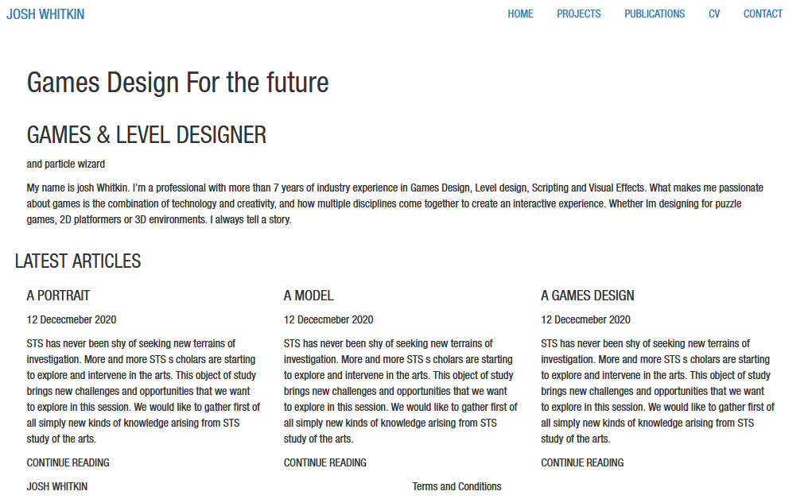

Go to https://validator.w3.org/#validate_by_input
Copy and paste the whole index.html code and paste into the validator
You should have no errors, if you do fix them.

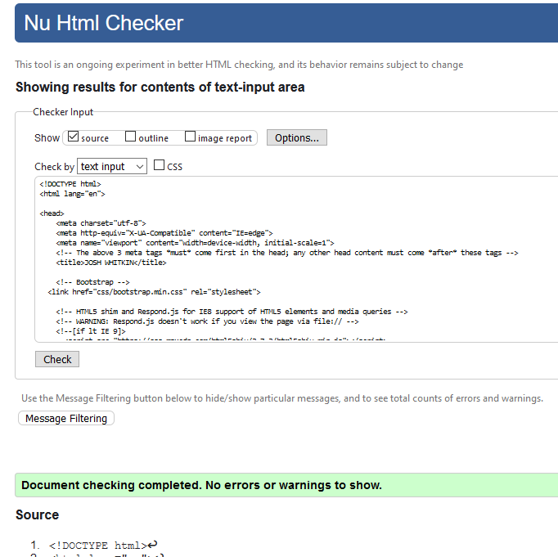

Now lets commit (tell Github Desktop to start recording the changes we make) and push (or upload our changes to our online Github account)

First we need to commit all the a changes we have made to Joshs site- unfortunatelt you have to add select one file at a time and commit each file.

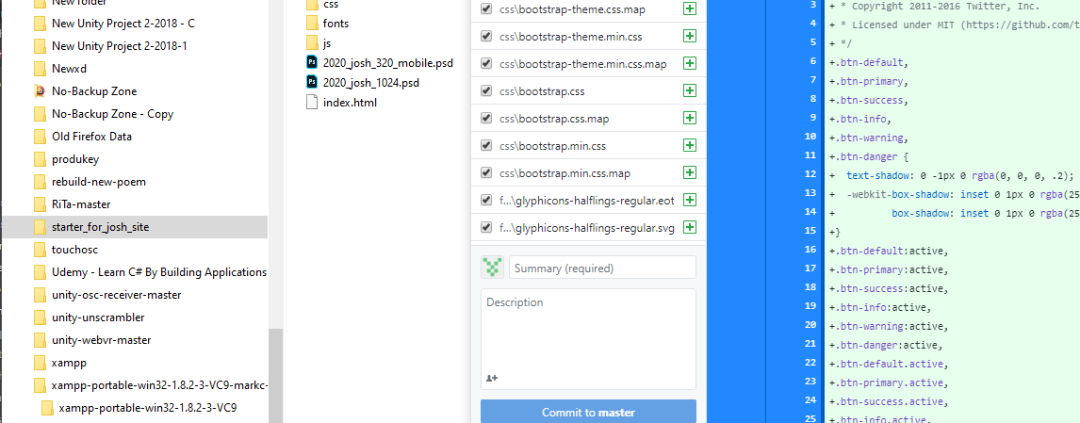

Now we can push (or upload) these file into our online Github respository
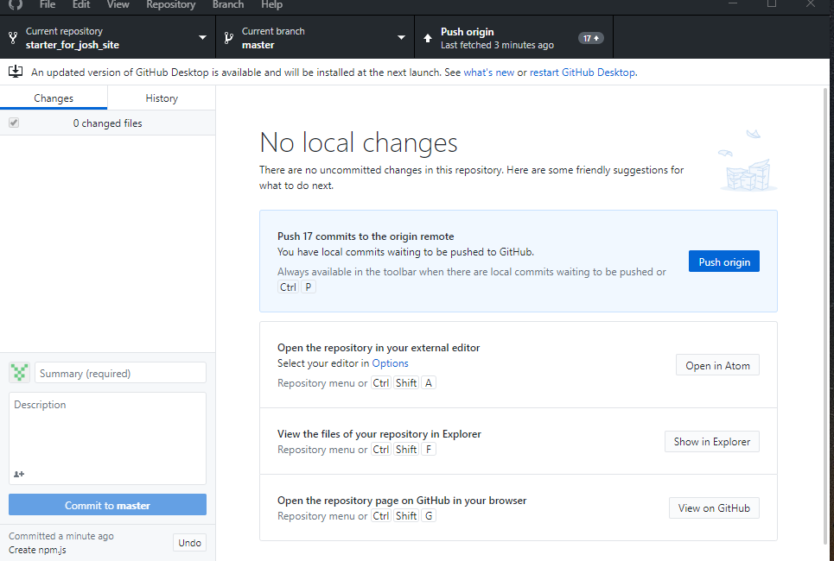

Our local folder structure and content should now be reproduced in your online Github repository
